# Project Development Phase Model Performance Test

|  |  |
| --- | --- |
| Date | 18 November 2022 |
| Team ID | PNT2022TMID06636 |
| Project Name | Project – Web Phishing Detection |
| Maximum Marks | 10 Marks |

## Model Performance Testing:

Project team shall fill the following information in model performance testing template.

|  |  |  |  |
| --- | --- | --- | --- |
| **S.No.** | **Parameter** | **Values** | **Screenshot** |
| 1. | Metrics | **Regression Model: Logistic Regression**  MAE – 0.26142017186793304  MSE - 0.5228403437358661  RMSE - 0.7230769971004928 R2 score - -2.888673182487615  **Classification Model: Decision Tree Classifier**  Confusion Matrix - array([[ 61, 249],  [ 26, 1875]])  Accuracy Score- 0.8756218905472637  Classification Report – refer screenshot | Attached Below |
| 2. | Tune the Model | Hyperparameter Tuning - Validation Method - | Attached Below |

# METRICS:

**REGRESSION MODEL:** LOGISTIC REGRESSION

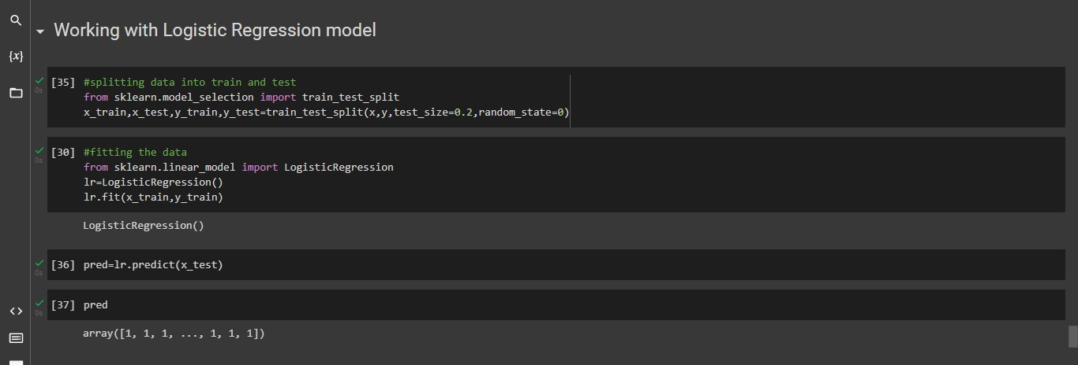

## EVALUATION METRICS:

Here are some evaluation metrics used for regression they are,

* + R2 Score
  + Mean Square Error(MSE)
  + RMSE(Root Mean Square Error)
  + Mean Absolute Error(MAE)

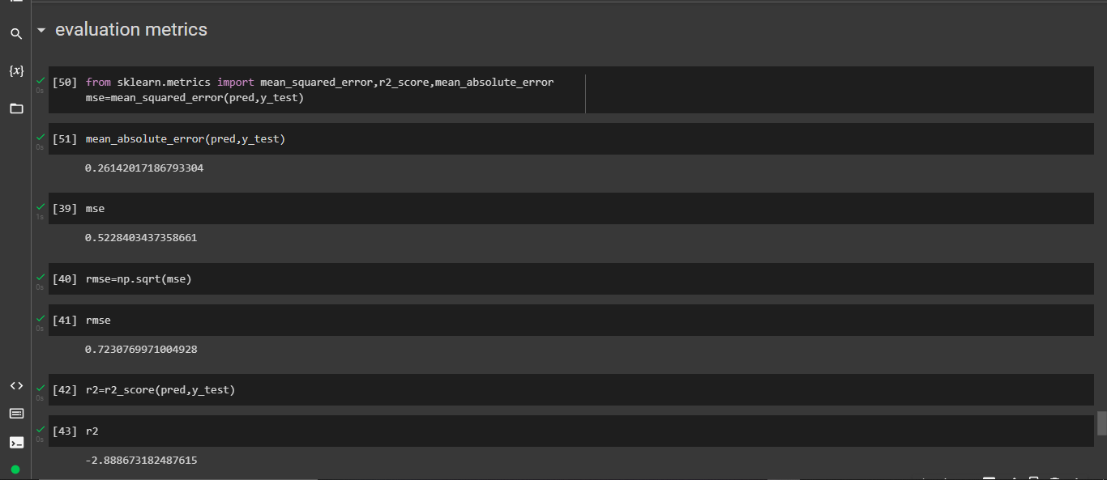

**CLASSIFICATION MODEL:** DECISION TREE CLASSIFIER

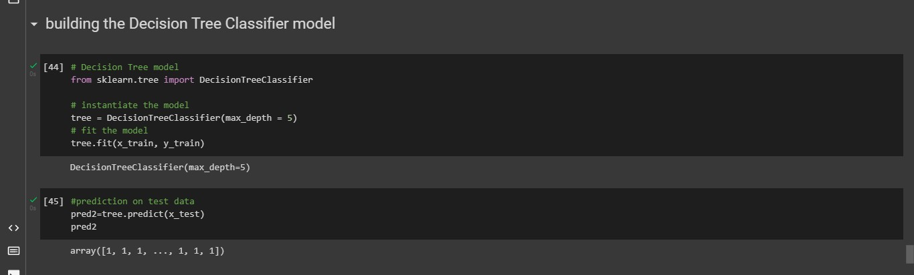

## EVALUATION METRICS:

Some of the evaluation metrics is as follows

* + Confusion matrix
  + Accuracy score
  + Classification report

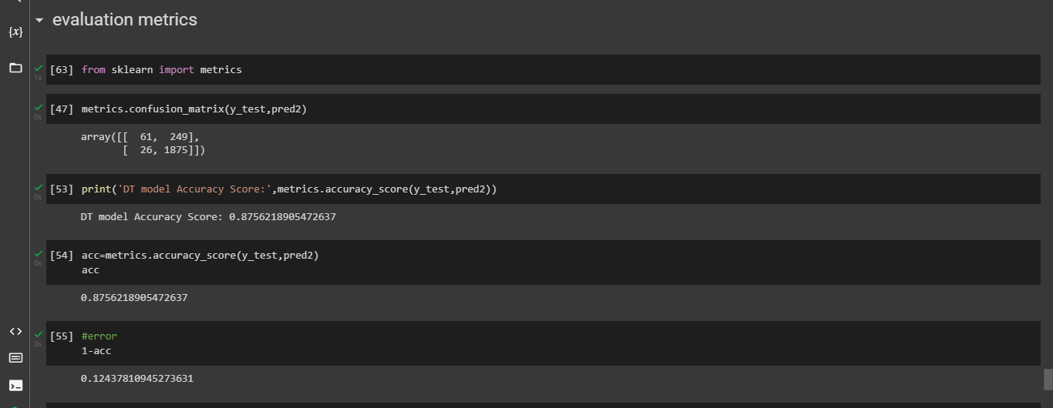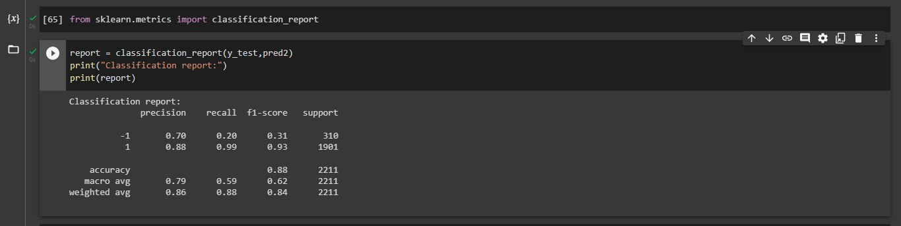

1. **TUNE THE MODEL:** DECISION TREE CLASSIFIER

## HYPERPARAMETER TUNING:

